**kINTI International College Penang School of Engineering and Technology**

**3+0 Bachelor of Science (Hons) in Computer Science, in collaboration with Coventry University, UK**

**3+0 Bachelor of Science (Hons) in Computing, in collaboration with Coventry University, UK**

**Coursework cover sheet**

**Section A - To be completed by the student**

|  |  |
| --- | --- |
| Full Name: CHU ZHI XUAN | |
| CU Student ID Number:12673128 | |
| Semester: JAN 2022 | |
| Session:  **April 2022** | |
| Lecturer:  **Nadhrah Abdul Hadi (nadhrah.abdulhadi@newinti.edu.my)** | |
| Module Code and Title:  **4067CEM Software Design** | |
| Assignment No. / Title:  **Continuous Assessment** | % of Module Mark:  **50** |
| Hand out Date:  **22nd April 2022** | Due Date:  **Task 1: 13 May 2022, by 11.59pm**  **Task 2: 1 July 2022, by 11.59pm**  **Task 3: 17 June 2022, by 11.59pm.**  **Task 4: 17 June 2022, by 11.59pm.**  **Task 5: 17 June 2022, by 11.59pm.** |
| Penalties: No late work will be accepted. If you are unable to submit coursework on time due to extenuating circumstances, you may be eligible for an extension. Please consult the lecturer. | |
| Declaration: I/we the undersigned confirm that I/we have read and agree to abide by the University regulations on plagiarism and cheating and Faculty coursework policies and procedures. I/we confirm that this piece of work is my/our own. I/we consent to appropriate storage of our work for plagiarism checking.  Signature(s): ________________________ | |

**Section B - To be completed by the module leader**

|  |  |  |
| --- | --- | --- |
| Intended learning outcomes assessed by this work:  1. Understand and apply appropriate concepts, tools and techniques to each stage of the software development  2. Understand and apply design patterns to software components in developing new software  3. Demonstrate an understanding of project planning and working to agreed deadlines, along with professional, interpersonal skills and effective communication required for software production  5. Demonstrate an awareness of, and ability to apply, social, professional, legal and ethical standards as documented in relevant laws and professional codes of conduct such as that of the Malaysian National Computer Confederation. | | |
| Marking scheme | Max | Mark |
| 1. User Story Mapping 2. Setting up a GitHub Repository 3. Creating a Class diagram and design pattern selection 4. Creating a Prototype User Interface and Usability Testing 5. Discuss the ethical issue related to the software | 20  10  30  20  20 |  |
| Total | 100 |  |

**Class diagram**

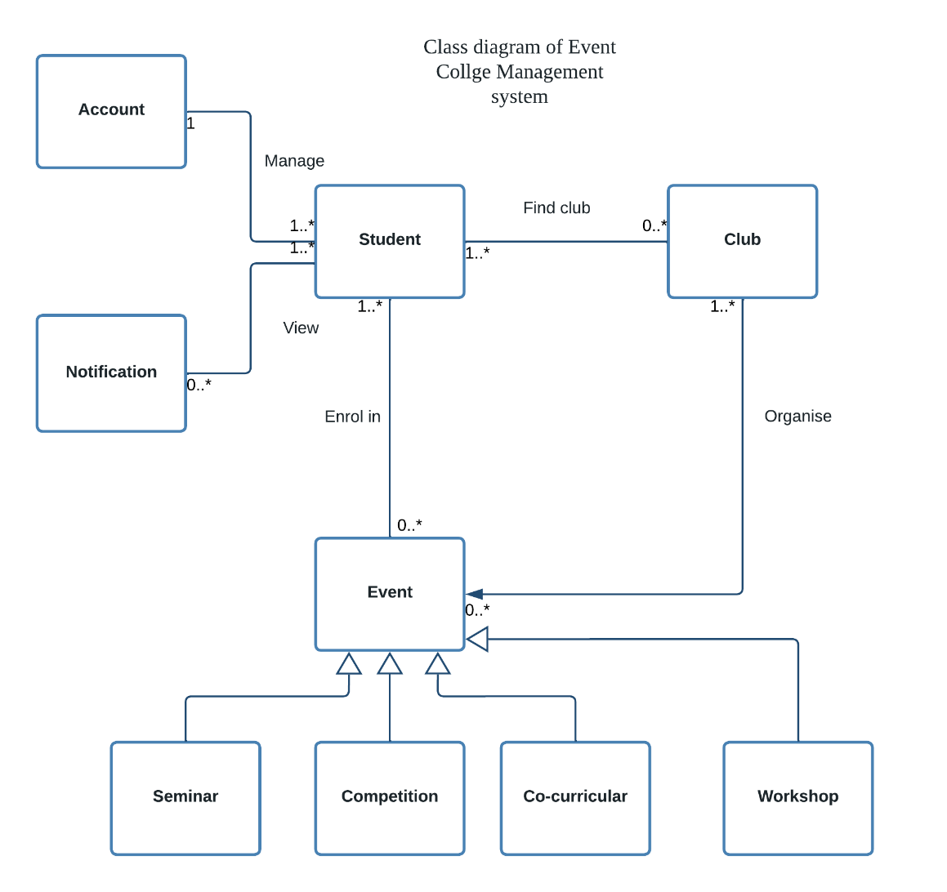

Student: Find and join the club, manage the account, view the notification, enrol the event

Club : Organise the event, send the notification to club member

Event : The seminar, competition, co-curricular and workshop consider as the inheritance of event.

Notification: Able to view the notification send by club and event, manage to turn on/off notification

Account: Able to change the username, email, password, upload the profile picture

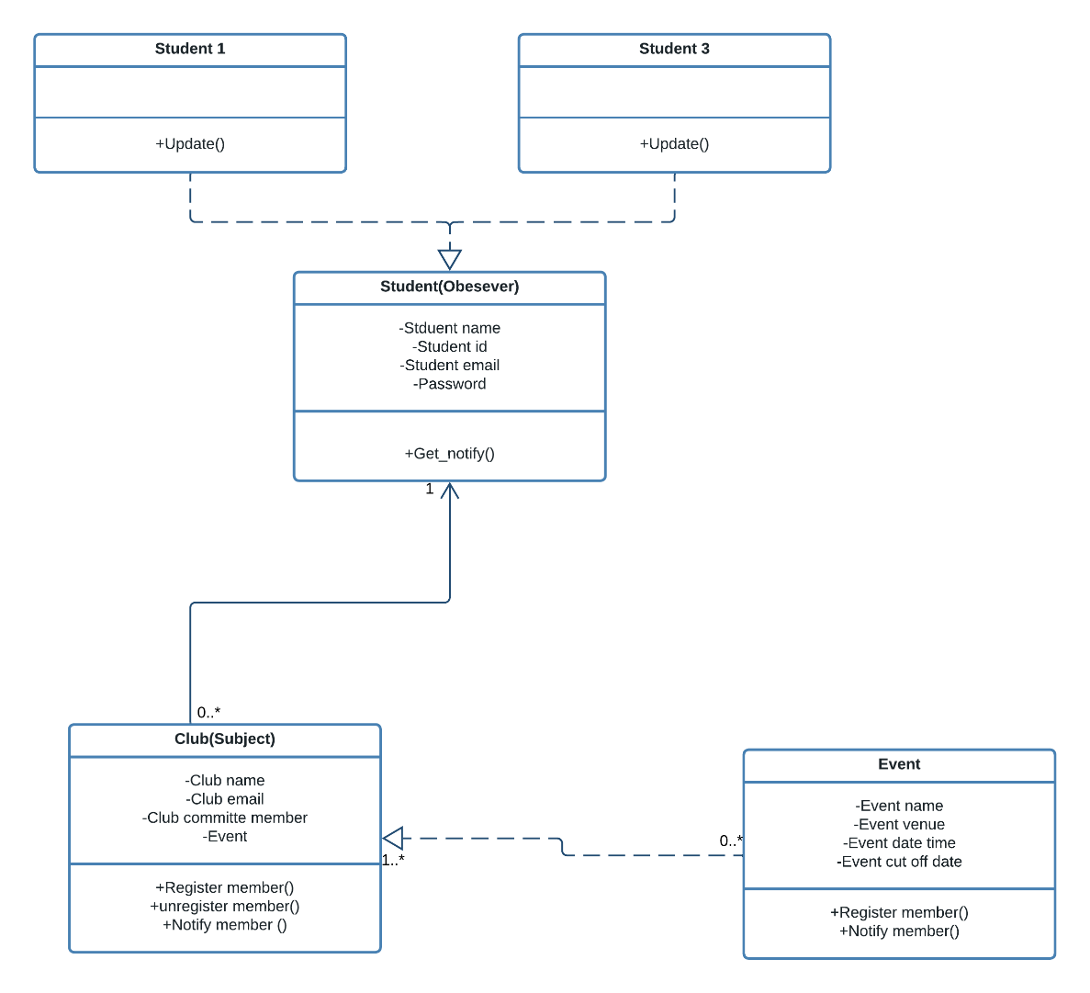**UML Diagram**

Problem: How does the notification will send by club to only the student is club member if there are new event published in the website?

Solution: Use observer design pattern. The club act as a subject that manage the club member (Observer) as the Observer list. If the new event come out (concrete subject), the club will send notification to the Observer. The reason to choose observe design pattern can filter out non-registered member before sending new event notification to respective club member.

Subject -Register the student as member , maintain the current observer list, notify the observer when get concrete subject has changed

Observer – pull the information from subject , get new notifications from subject, register the subject